  
Name : Azaria Cindy Sahasika

Number Id : 2341760169 / 06

Class : 1G – Business Information System

Lesson : Algorithm and Data Structure

Material : Exercise 4 - week 5

Github Link : <https://github.com/azariacindy/algorithm-ds>

1. Buatlah flowchart untuk menghitung nilai akar dari suatu bilangan dengan algoritma Brute Force dan Divide Conquer! Jika bilangan tersebut bukan merupakan kuadrat sempurna, bulatkan angka ke bawah.
2. Brute Force

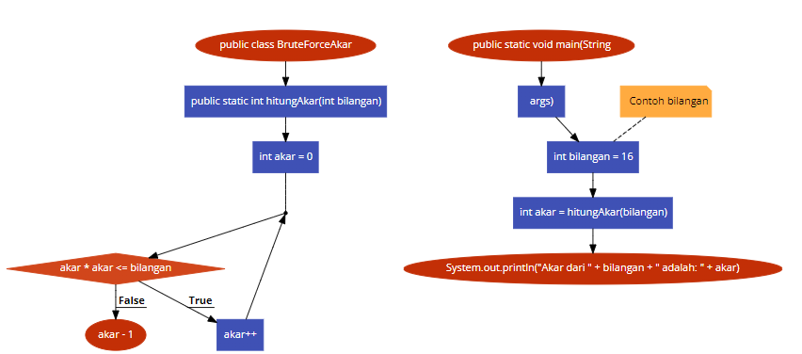

1. Divide Conquer

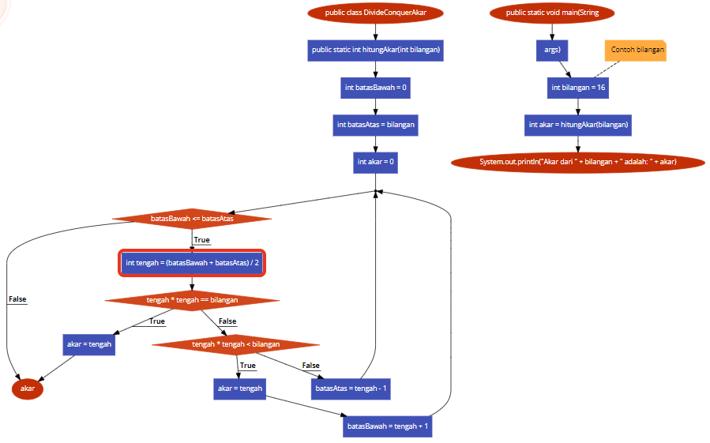

1. Buatlah flowchart untuk menghitung hasil pangkat dari inputan suatu bilangan dengan algoritma Brute Force dan Divide Conquer!
2. Brute Force

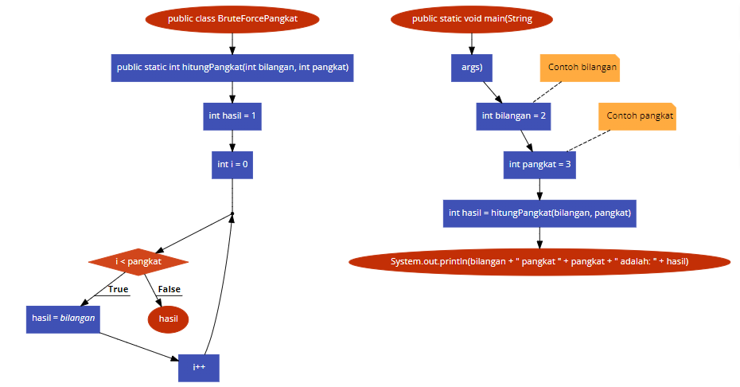

1. Divide Conquer

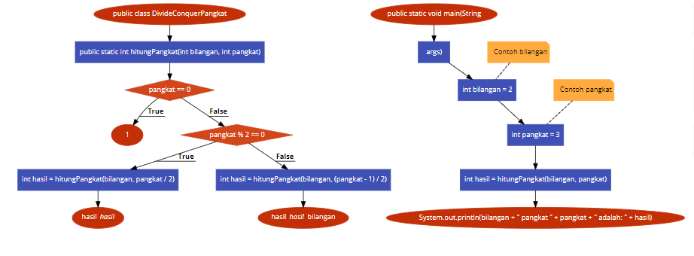

1. Tentukan notasi Big O yang sesuai dari kode program berikut!

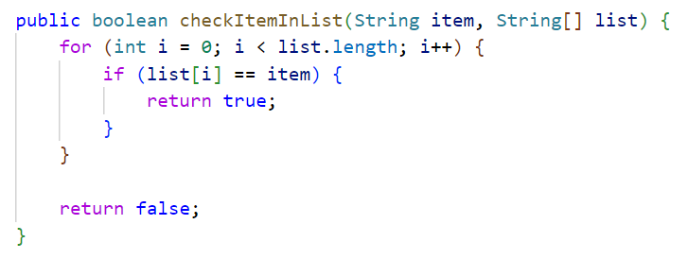

The dominant factor in the Big O notation for this code is the for loop.

This loop repeats a certain amount of time based on the length of the input list (n).

In the worst-case scenario, the loop will loop through the entire list (n times) before finding a match or reaching the end of the list.

Hence, the time complexity of this function increases linearly with the size of the input list (n).

The Big O notation highlights the overall efficiency of the algorithm as the input size increases. The time complexity of the checkItemInList function is linear (O(n)), which means the time taken to run the function increases proportionally with the list size.